|  |
| --- |
| **National University of Computer and Emerging**  **Sciences** |
| In Lab Exercise  “Data Retrieval Select-from-where Join Order by” |
| Database Systems Lab |
| Spring 2023 |

Department of Computer Science FAST-NU, Lahore, Pakistan

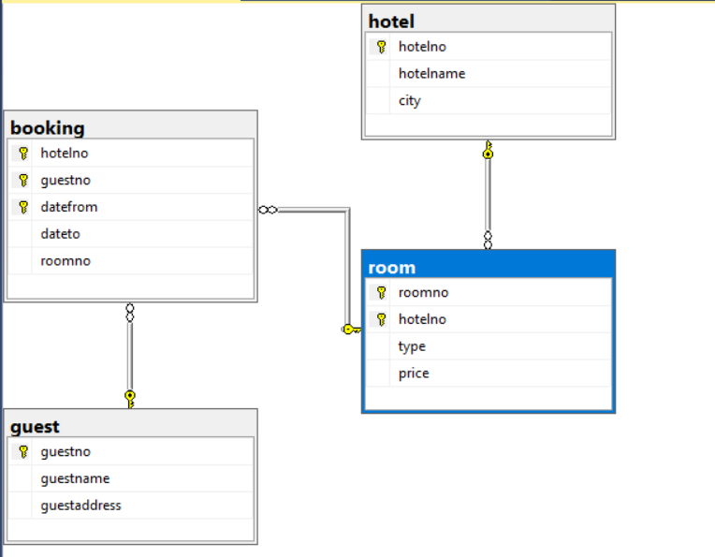

**You are given a script.sql , create your database and create table and populate data in your db.**

1. List all hotels which are in London. Order the result in descending order by hotel name.
2. List all hotels whose name’s third alphabet has a ‘t’.
3. List all bookings whose dateto column is NULL.
4. List the guest name and guest address of those guests who are from Glasgow and their first name is Tony or last name is Farrel.
5. List all the room nos. which were booked in the period 2005-2010. Also display the room’s hotel

no.

1. List all the rooms of hotel no. 1001 which are of single type and the price is between 20 to 40.
2. List the room no. along with its hotel no. whose price is maximum.

# Do the following question in 2 ways: Use ‘+’ operator as well as concat function.

1. Show the data of hotel table as :

The hotel whose id is (id) is in (city) and its name is (name).

# Example:

The hotel whose is id isdc01 is in Berlin and its name is Latham.

1. List all the hotels which have double as well as family type rooms.
2. List all the hotels which have single as well as double type rooms but no family type room.
3. List all the rooms which have been booked by either guest no. 10003 or by guest no. 1007 but not by guest no 1001.